DEPARTMENT OF MINING ENGINEERING

MinE300 / MinE400
Summer Practice Report

NAME OF THE COMPANY

Name and Surname of Student
Student ID
Period of Summer Practice

ABSTRACT
A summary of the Summer Practice Report, not exceeding 200 words, should be given in this section.

ACKNOWLEDGEMENTS
In this section, the student may extend his/her thanks to those who were helpful during the summer practice.

TABLE OF CONTENTS

ABSTRACT 2
ACKNOWLEDGEMENTS 3
TABLE OF CONTENTS 4
LIST OF FIGURES 5
LIST OF TABLES 6
1 INTRODUCTION (common title for all types of physical summer practices) 7
2 COMPANY INFORMATION (common title for all types of physical summer practices) 8
3 AREAL INFORMATION (not included for summer practices in consultancy companies) 8
4 GEOLOGICAL INFORMATION (not included for summer practices in consultancy companies) 8
5 OPERATIONAL INFORMATION (not included for summer practices in consultancy companies) 8
6 MINING-RELATED WORKS IN THE COMPANY (included only for summer practices in consultancy companies) 9
6.1 Mining License Applications (Example) 9
6.2 Rehabilitation Project (Example) 9
7 PERSONAL STUDY (common title for all types of physical summer practices) 10
7.1 The Aim of the Personal Study 10
7.2 Data Acquisition 10
7.3 Analyses and Calculations 10
7.4 Results and Conclusions of the Personal Study 10
8 CONCLUSIONS (common title for all types of physical summer practices) 10
9 REFERENCES (common title for all types of physical summer practices) 10
APPENDICES (common title for all types of physical summer practices) 11
A. THE MINING AREA FROM DIFFERENT VIEWPOINT 11
B. PROCESSING PLANT EQUIPMENT IN THE MINING AREA 12

LIST OF FIGURES

FIGURES
Figure 1. How to Arrange Paragraph Spacing in a Report 7
Figure A. 1. View of the Mine Pits at the Northern Side 11
Figure A. 2. View of the Mine Pits at the Southern Side 11
Figure B. 1. Grinding Mills in the Mine 12
Figure B. 2. Crushing and Screening in the Mine 12

LIST OF TABLES

TABLES
Table 1. Summer Practice Record of Student B 7

INTRODUCTION (common title for all types of physical summer practices)
This report should be written in English in A4 page size with the normal layout margin (2.54 cm free space from the page sides). The font size should be 12 points, Times New Roman, where line spacing should be set 1.5 lines. All figures and tables should be numbered appropriately and placed in the report's main body, as given below.

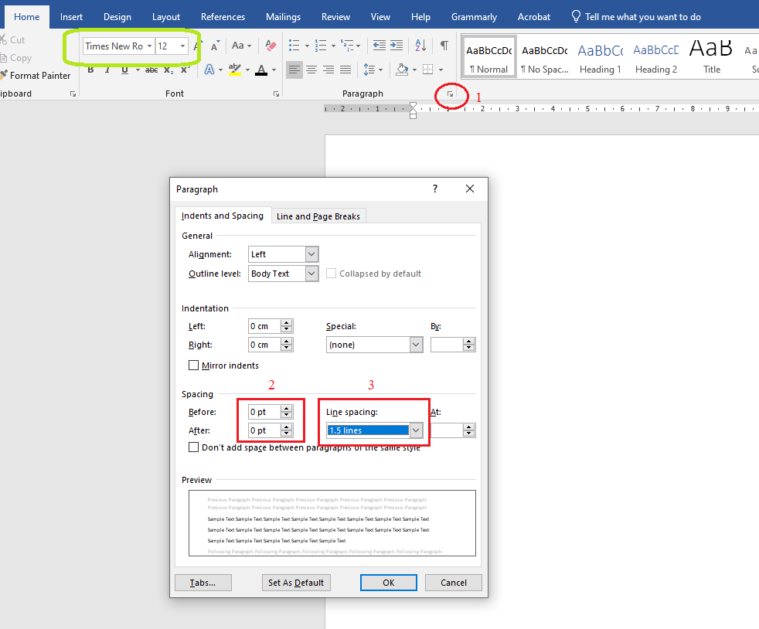

Figure 1. How to Arrange Paragraph Spacing in a Report

Figure captions should be located below the figures while table captions should be located above the tables. 1 (one) line should be left before/after the captions and before/after each figure and table.

Table 1. Summer Practice Record of Student B

Summer Practice Area | Company Name | Course Code
Underground Mining - Field | TUPRAG Efemcukuru | MinE300
Surface Mining - Field | KOZA Altın Kaymaz | MinE400
Mineral Processing - Field | - | -
Mining Consultancy | MITTO Consultancy | Voluntary Summer Practice

In the Introduction Section, the aim and the scope of the summer practice should be presented briefly. Students must mention their primary practice subjects and what they studied during the practice period.

COMPANY INFORMATION (common title for all types of physical summer practices)
Students should give information about the company name, address, business activities, company history, organizational structure, and similar topics related to the company's mining activities.

AREAL INFORMATION (not included for summer practices in consultancy companies)
Students should give information about the location of the mine, the topography of the area, climate, flora and fauna, the communities' social and economic structure in the mining area, infrastructure including transportation and connections, port facilities, water, and electricity support industries.

GEOLOGICAL INFORMATION (not included for summer practices in consultancy companies)
Mineralogy, petrography, physical geology and, grade and reserve of the ore deposit should be given in this section.

OPERATIONAL INFORMATION (not included for summer practices in consultancy companies)
The primary field of summer practice (underground mining, surface mining, mineral processing, or any related operation) should be covered in detail. Students should report on the methods employed, equipment and materials used, workforce, products, quality control, cost, marketing, environmental and safety practices, research and development (R&D) activities, and all the related operational aspects of the company in the area.

MINING-RELATED WORKS IN THE COMPANY (included only for summer practices in consultancy companies)
Students who perform their summer practices in mining consultancy companies should give detailed information about the company's mining-related projects. Students should discuss these projects under one or multiple of the following sub-topics:
Operation-Related (Office Works):
- Mining License Applications (Maden Ruhsat Müracaatları)
- Opening a Business and Working License Permits (İşyeri Açma ve Çalışma Ruhsatları)
- Drilling Permits (Sondaj İzni)
- Mine Mapping and Topographical Works (Maden Haritalama ve Topografya Çalışmaları)
- Mineral Exploration Projects (Maden Arama Projeleri)
- Mining Business Projects (Maden İşletme Projeleri)
- Rehabilitation Projects (Maden Rehabilitasyon Projeleri)

Operation-Related (Field Works):
- Geological Survey (Jeolojik Etüt)
- Geotechnical Survey (Jeoteknik Etüt)
- Geochemical Exploration (Jeokimyasal Arama)
- Hydrogeological Field Works (Hidrojeoloji Arazi Çalışmaları)
- Stability Analysis (Duraylılık Analizleri)
- Seismic Hazard Analysis (Sismik Tehlike Analizleri)

Environment-Related:
- Acid Rock and Acid Mine Drainage (Asit Kaya Drenajı ve Asit Maden Drenajı)
- Mine Waste Management (Maden Atık Yönetimi)
- Environmental Impact Assessment (EIA) Permits (ÇED İzinleri)
- Environmental Permits (Çevre İzinleri)
- Hydrogeological Works (Hidrojeolojik Çalışmalar)
- Mine Dewatering Works (Maden Susuzlandırma Projeleri)

As an example, if the company is performing projects related to Mining License Applications and Rehabilitation Studies, then the student should discuss them under the following titles:

Mining License Applications (Example)
Under this sub-topic, students should give brief information about the description, location, scope, work packages, activities of each project by using related illustrations.

Rehabilitation Project (Example)
Under this sub-topic, students should give brief information about the description, location, scope, work packages, activities of each project by using related illustrations.

PERSONAL STUDY (common title for all types of physical summer practices)
A specific and quantitative study should be performed by each student and should be stated under this section with the following mandatory sub-topics:

The Aim of the Personal Study
The main objectives of the study and the reasons for conducting such study should be stated.

Data Acquisition
The type, nature, and source of data collected for the study should be explained.

Analyses and Calculations
The computations and related analyses performed should be given.

Results and Conclusions of the Personal Study
The main conclusions derived from the computations and the level of achievement for the
objectives should be stated.

CONCLUSIONS (common title for all types of physical summer practices)
Summer practice activities carried out by the students, and the significant findings should be summarized. Recommendations, if any, should be provided under this section.

REFERENCES (common title for all types of physical summer practices)
All cited information should be referred to in the text and listed in the references section in the format given below. Violation of citation rules is an act of plagiarism, which is a serious disciplinary offense.

Please check out the APA Documentation from the link below to see how to write in-text citation and References according to APA Style. You may also read the Plagiarism document of the METU Academic Writing Center from the same link as follows:
https://awc.metu.edu.tr/handouts

APPENDICES (common title for all types of physical summer practices)
All material that students wish to file separately from the text's main body should be compiled in this section and referred to in the text whenever needed. Related figures can be located under different appendix titles as given below. Figure and table caption numbers need to be generated according to the Appendix Code (A, B, C,…):

- THE MINING AREA FROM DIFFERENT VIEWPOINTS

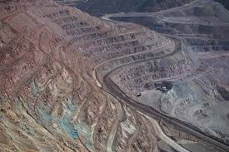
Figure A. 1. View of the Mine Pits at the Northern Side
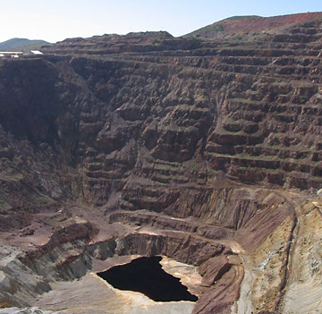
Figure A. 2. View of the Mine Pits at the Southern Side

- PROCESSING PLANT EQUIPMENT IN THE MINING AREA

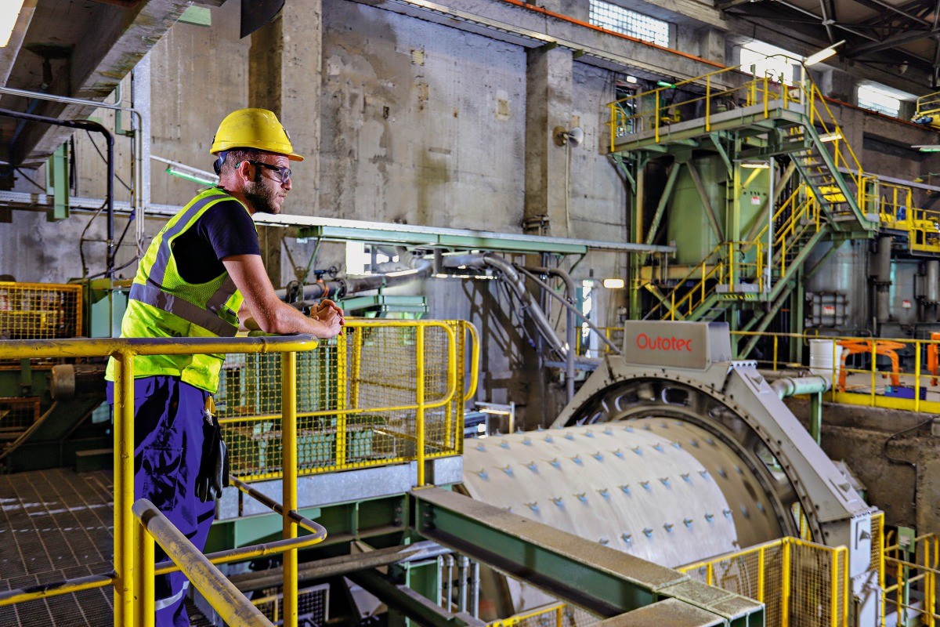
Figure B. 1. Grinding Mills in the Mine

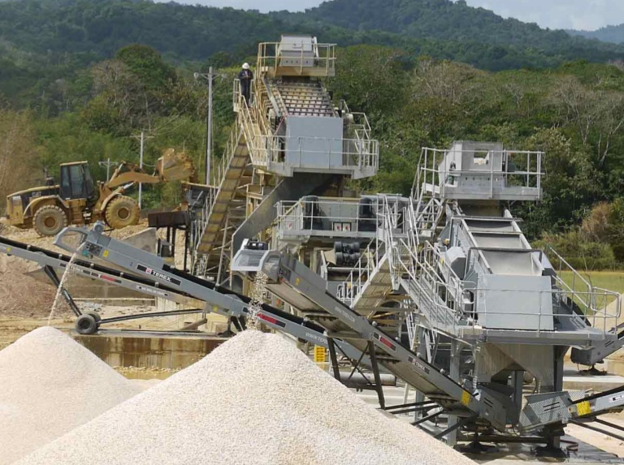
Figure B. 2. Crushing and Screening System in the Mine

