

**DEPARTMENT OF MINING ENGINEERING**

MinE300 / MinE400

Summer Practice Report

Mineral Processing

NAME OF THE COMPANY

Name and Surname of Student

Student ID

Period of Summer Practice

ABSTRACT

A summary of the Summer Practice Report, ***not exceeding 200 words***, should be given in this section.

**Keywords:** State five technical keywords defining your summer practice experience. Insert a comma between keywords.

ACKNOWLEDGEMENTS

In this section, the student may extend his/her thanks to those who were helpful during the summer practice.

TABLE OF CONTENTS

ABSTRACT ii

ACKNOWLEDGEMENTS iii

TABLE OF CONTENTS iv

LIST OF TABLES v

LIST OF FIGURES vi

1 INTRODUCTION 1

2 COMPANY 2

3 MINING AREA 2

4 GENERAL INFORMATION ON SITE GEOLOGY AND ORE DEPOSIT 2

5 OPERATION 3

6 PERSONAL STUDY 4

6.1 Objective 4

6.2 Dataset and Data Acquisition 4

6.3 Analyses and Calculations 4

6.4 Results and Discussions 4

6.5 Observations about Plant/Mining Operation 4

7 CONCLUSIONS AND RECOMMENDATIONS 5

8 REFERENCES 5

APPENDICES 6

A. THE MINING AREA FROM DIFFERENT VIEWPOINTS *(Example-1)* 6

B. PROCESSING PLANT EQUIPMENT IN THE MINING AREA *(Example-2)* 7

LIST OF TABLES

**TABLES**

**Table 1.** Summer Practice Record of Student B 1

LIST OF FIGURES

**FIGURES**

**Figure 1.** How to Arrange Paragraph Spacing in a Report 1

**Figure A. 1**. View of the Mine Pits at the Northern Side 6

**Figure A. 2**. View of the Mine Pits at the Southern Side 6

**Figure B. 1.** Grinding Mills in the Mine 7

**Figure B. 2.** Crushing and Screening in the Mine 7

# INTRODUCTION

This report should be written in English, with an A4 page size and a normal layout margin (2.54 cm free space from the page sides). The font size should be 12 points, Times New Roman, where line spacing should be set to 1.5 lines. All figures and tables should be numbered appropriately and placed in the report's main body, as given below. Each figure and table must be cited and discussed with their caption numbers in the text.

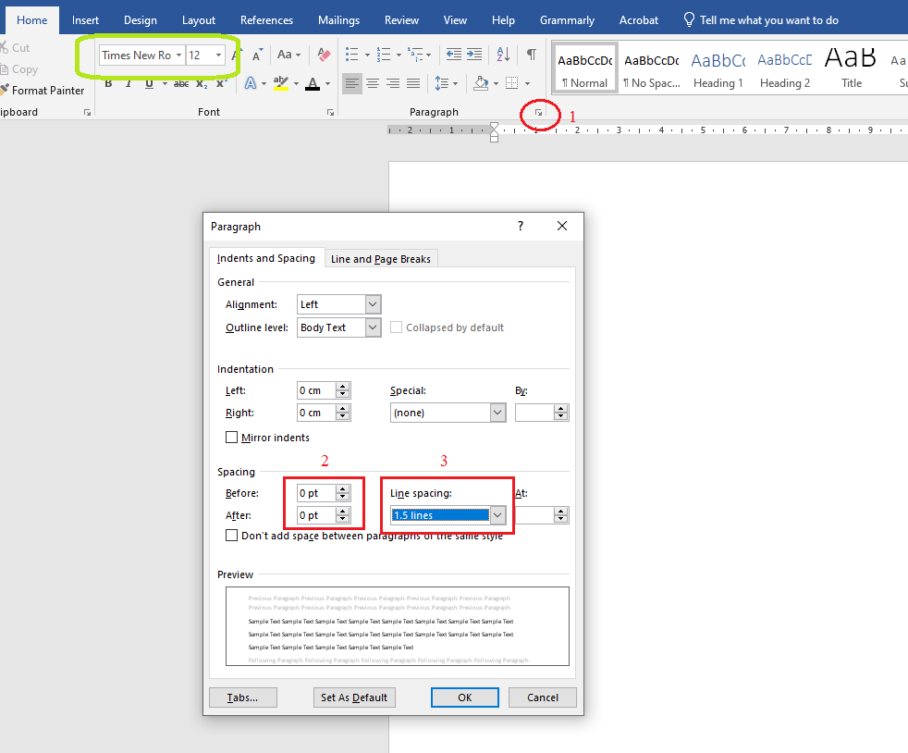

**Figure 1.** How to Arrange Paragraph Spacing in a Report

Figure captions should be located below the figures, while table captions should be located above the tables.

**Table 1.** Summer Practice Record of Student B

|  |  |  |
| --- | --- | --- |
| **Summer Practice Area** | **Company Name** | **Course Code** |
| Underground Mining - Field | TUPRAG Efemcukuru | MinE300 |
| Surface Mining - Field | KOZA Altın Kaymaz | MinE400 |
| Mineral Processing - Field | - | - |
| Mining Consultancy | MITTO Consultancy | Voluntary Summer Practice |

The Introduction Section should briefly present the summer practice's aim and scope. Students must mention their primary practice subjects and studies experienced during the practice period.

# COMPANY

Students should give information about

* the company name and address,
* business activities of the company, including the other mining activities at different sites and the market(s) they are active in,
* the company history,
* the organizational structure.

# MINING AREA

Students should give information about

* location and topography of the mining area,
* climate, flora, and fauna active in or near the mining site,
* the communities' social and economic structure in the mining area,
* available infrastructure, including transportation and connections, port facilities, water and electricity support industries,
* mine layout showing the comparative locations of surface and social facilities within the mining license area, including operational areas, processing plant, administrative building, mechanical workshop, warehouse, camp, health care and rescue centers, cafeteria, dressing and cleaning rooms, entertainment places, sports areas, etc.

# GENERAL INFORMATION ON SITE GEOLOGY AND ORE DEPOSIT

Students should give information about

* mineralogy,
* petrography,
* structural geology,
* detailed information about the ore deposit, including average ore grade, range of ore grade, mining economic cut-off grade, milling economic cut-off grade, the total amount of remaining reserve in volume and in weight, specific gravity or tonnage factor of ore and overburden and thickness, slope, and direction of the reserve.

# OPERATION

Students should give information about

* Mining Method and Mining Operations: Implemented mining method and brief discussion about the mining operations,
* Ore and Waste Production Rates: Annual ore production in tonnes and waste stripping in m3, life of mine (LOM), quality and quantity of the final and by-product(s) produced as run-of-mine/concentrate/metal to be sold to the market and potential customers,
* Occupational Health and Safety: Implemented occupational health and safety management system and its details with particular emphasis on the accident prevention and hazard control program in the mining site,
* Environment: Environmental management plan and implementation, including land quality, water quality, and air quality-related applications, regulations, and policies.
* Corporate Social Responsibility: Management engagement with the social community of stakeholders and applications related to the company's social responsibilities.
* Mineralogy and Petrography: Chemical and physical properties of ore and gauge minerals, grade, and ore mineralogy,
* Mineral Processing:
  + Comminution method, equipment, circuit, and all relevant technical details,
  + Classification method, equipment, circuit, and all relevant technical details (Screens, cyclones, spirals, etc.),
  + Concentration method, equipment, circuit, and all relevant technical details (Gravity separation, magnetic separation, flotation, leaching etc.). If flotation and/or leaching is the method being used, reagent names and dosages should be listed.
  + Dewatering method, equipment, circuit, and all relevant technical details (Thickener, filtration, etc.), reagent names, and dosages should be listed if flocculant or such reagent is being used.
  + Water management and balance
  + Waste, tailings & effluent management ,
  + Grade and recovery, metallurgical accounting, mineral classification & separation efficiency,
  + Mass Balance Calculations,
  + Detailed flowsheet with all related details.

# PERSONAL STUDY

A specific and ***quantitative*** study should be performed by each student and should be stated under this section with the following ***mandatory sub-topics****:*

## Objective

The study's main objectives, scopes (boundaries), and the reasons for conducting such a study should be stated.

## Dataset and Data Acquisition

The datasets to be used in Section 6.4 should be given here previously, with a discussion on the data acquisition/collection process and data observation period. Data units should also be stated.

## Analyses and Calculations

All the computational stages, including analyses, calculations, and assumptions, should be mentioned here and discussed technically and extensively. The methodology to obtain the findings should be stated step by step with references if available.

## Results and Discussions

The main findings derived from the computations and the level of achievement for the objectives should be stated. Make the relevant interpretations of these results and discuss the findings.

## Observations about Plant/Mining Operation

State your engineering observations and criticism on mining operations or plant activities where the personal study is performed.

# CONCLUSIONS AND RECOMMENDATIONS

Professional engineering experiences during the summer practice period and the significant findings and observations should be summarized. Future recommendations for the technical activities of mine where you were involved should be provided under this section.

# REFERENCES

All cited information should be referred to in the text and listed in the references section in the format given below. Violation of citation rules is an act of plagiarism, which is a serious disciplinary offense.

Please check out the **APA Documentation** from the link below to learn how to write in-text citations and references according to APA Style. You may also read the Plagiarism document of the METU Academic Writing Center from the same link as follows:

<https://awc.metu.edu.tr/en/writing-academic-purposes>

APPENDICES

If you have multiple similar figures that can overcrowd the main text, you can insert those figures in the appendices. For instance, if you have more than one figure for the mine pits, you can use one representative figure in the main text and locate the others in the appendices. As given below, similar figure groups can be located under different appendix titles. Figure and table caption numbers need to be generated according to the Appendix Code (A, B, C,…):

1. THE MINING AREA FROM DIFFERENT VIEWPOINTS *(Example-1)*

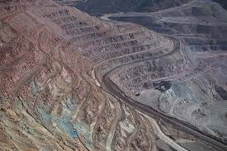

**Figure A. 1**. View of the Mine Pits at the Northern Side

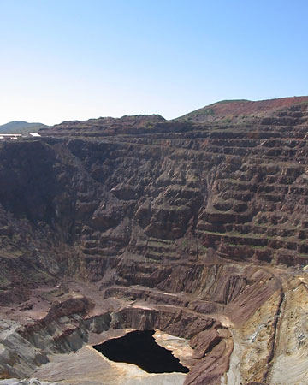

**Figure A. 2**. View of the Mine Pits at the Southern Side

1. PROCESSING PLANT EQUIPMENT IN THE MINING AREA *(Example-2)*

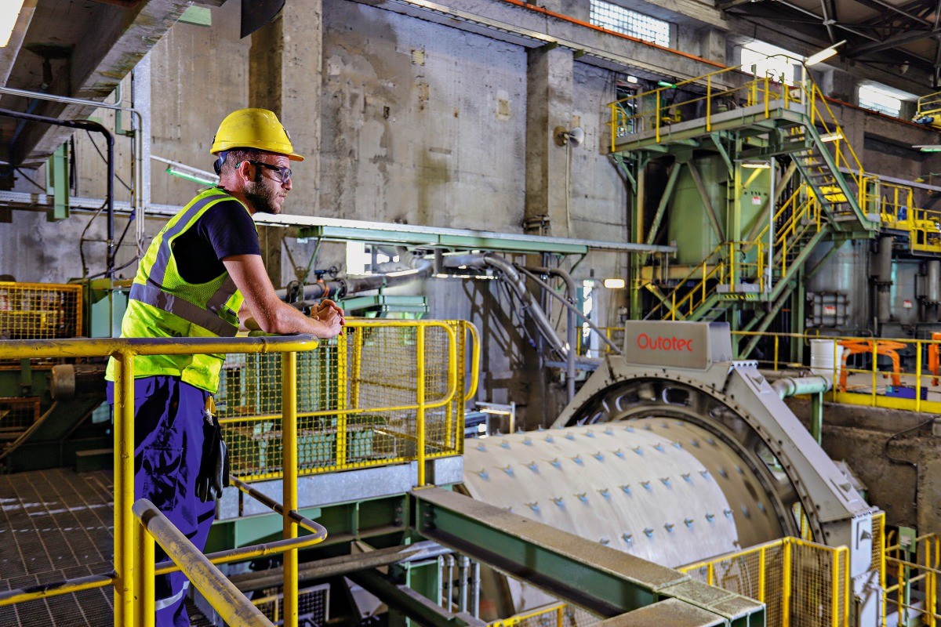

**Figure B. 1.** Grinding Mills in the Mine

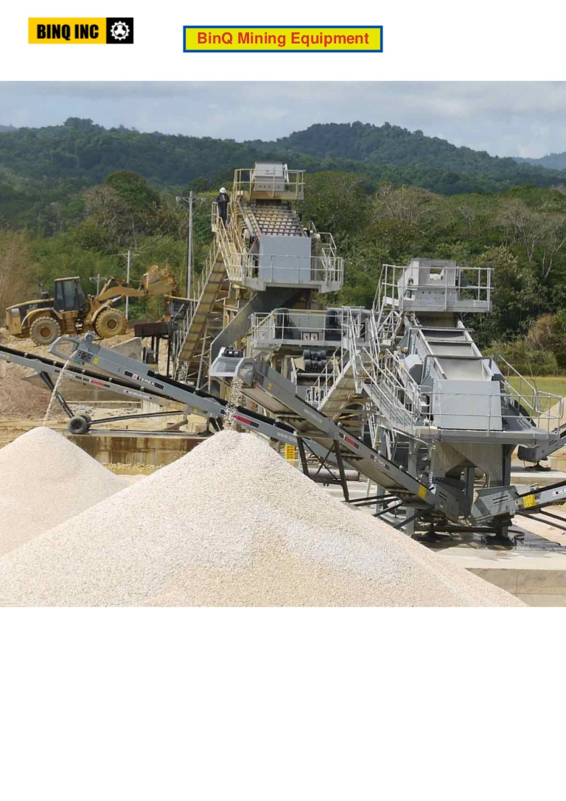

**Figure B. 2.** Crushing and Screening System in the Mine